Summary

MOOC Week 4: BATTERY & LIGHTING SYSTEMS

General description of the module
The goal of this module is to introduce the teachers to how the battery systems are implemented into modern vehicles. It should provide an overall understanding of how the field of knowledge from various science areas can be applied to modern vehicle battery systems.
Another goal of this module is to introduce the teachers to how headlamps and rear lamps are used in cars and to provide a system engineering understanding which allows teachers to assign experiments at school and content learned at school to specific Automotive functionalities.
Basic terms & concept of battery
Basic principle for all battery types is an electrochemical reaction. Batteries convert chemical energy to electric energy. A battery consists of cells, case and terminals. Each cell consists of electrolyte, positive and negative electrodes and separator. Anions and Cations are the ions which carry the charge. Anions are negatively charged ions and anions are the positively charged ions. Electrolyte is a chemical liquid-like medium lead acid, nickel cadmium, lithium iron. Separator is used to prevent the passage of metals, particles of the active matter and the sludge from the electrode of one polarity to the electrode of opposite polarity.
Common battery types found in automotive applications
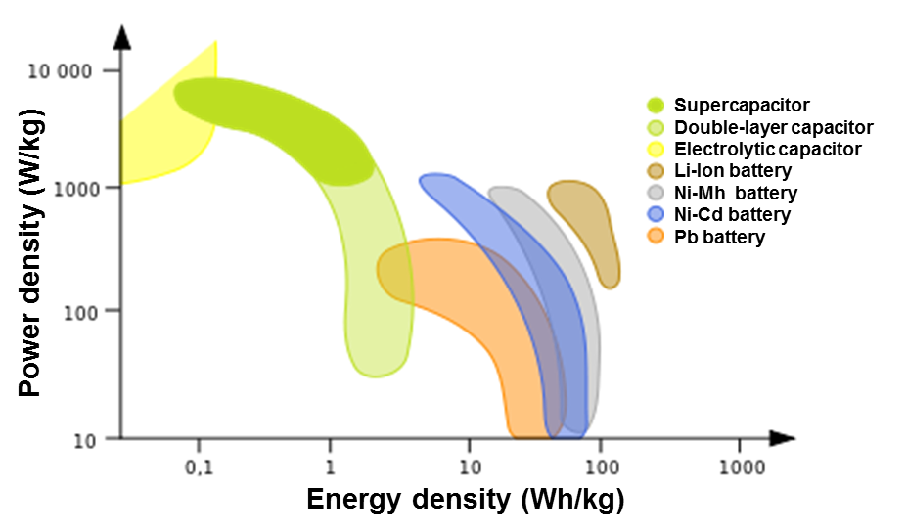
Lead-acid batteries
Nickel-Metal hydride batteries
Nickel-Cadmium batteries
Lithium Batteries
Lithium ion batteries
Lithium polymer
Lithium oxygen
Lithium sulphur

Figure 1 Power vs energy density by Elcap is licensed under CC0 1.0 Universal

Battery Management Systems
The BMS (Battery Management System) is one of the most important units in electric vehicle. An electric vehicle often requires fast and high current during the processes of charging and discharging, especially in HEV (Hybrid Electric Vehicle) applications. The BMS is an electronic system that manages cells in battery pack. The BMS is connected to the battery cells through a multitude of wires. The control unit is used to measure, estimate, and predict the operation possibilities for the upcoming time period.
The BMS must be able to decide whether the power from the source can be accepted or delivered to load, in order to keep the up with the vehicle performance. The control strategies used determine optimal energy usage and the battery life.
The communication through communication interface between all control units in real time, according to the rapidly changing driving conditions is crucial for a proper operation.

The BMS must to provide these following basic function:
- protect the cells or the battery from damage,
- prolong the life of the battery,
- maintain the battery in a state in which it can full fill the functional requirements of the application for which it was specified,
- monitor the conditions of individual cells which make up the battery pack, maintain all the cells within their operating limits.

Battery influences on the environment and human health
Batteries are made from a variety of chemicals, and metals which are in the batteries for the chemical reaction. Some of these materials are extremely toxic and poisonous, such as nickel, cadmium, lead, mercury, zinc, manganese, cobalt, chromium, vanadium and lithium.
Air pollution: Batteries are decomposed in landfills; the process of photochemical reaction takes place in the battery. It causes to the greenhouse effect, that is results in global warming / climate change.
They cause soil and water pollution: they do damage to soil micro-organisms and affect the breakdown of organic matter.
They threaten wildlife: accumulation in fish, it causes a reduction in their population.
New techniques used in electrochemistry can possible reduce the impact of battery on the environment and human health. Rechargeable battery systems have obviously a great advantage in this respect since they may be recharged and reused many times. More efficient waste sorting, reusing and component disposal of batteries.

Basic concepts of modern lighting systems
Adaptive front lighting system is one part of the active safety system of a middle- high end passenger car, providing an optimized vision to the driver during night time and other poor-sight conditions of the road by adapting the headlight angle and intensity, and judging the speed of the car, the steering wheel angle, the weather condition, and yaw and tilt rate of the car.
Oncoming traffic often forces the driver to dip the beam in order to avoid glaring of a traffic participant using the high beam. New lighting systems allow driving with high beam without glaring, because system use masking technique. It means that driving with permanently switched in high beam is possible by creating one light tunnel in time. This System is known as Camera based AFS – Glare free high beam system. Improvements of this system provides Camera based AFS – Matrix beam system, which can create more light tunnels on scene and get rid of mechanical system (rotating drum, stepper motor, gear …) to fully digital. Matrix LED system consist of Camera, Matrix LED control unit and Matrix LED light modules.

